Cypher Project

Defining The Problem:
Seafloor mapping remains one of the most complex and resource-intensive challenges for ocean exploration, with a significant portion of the world's oceans still unmapped. As of January 2025, nearly half of U.S. waters—around 46%—lack detailed maps, meaning they are without the crucial direct measurements of the seafloor that are essential for understanding and managing marine ecosystems, resources, and potential hazards. The difficulty of mapping the ocean floor arises from several factors, including the harsh environments of deep-sea exploration, the technical limitations of available equipment, and the substantial financial costs involved. Advanced technologies like sonar systems and remotely operated vehicles (ROVs) are essential for mapping, but they are not only expensive to develop and maintain but also require highly trained personnel for operation and troubleshooting. Moreover, conducting surveys in remote areas, often thousands of miles from shore, adds to the logistical costs, including fuel, ship operations, and the need for specialized crews. These financial burdens create a barrier to conducting comprehensive, widespread mapping efforts, leaving vast stretches of ocean unexplored and unmanaged. This money problem hinders progress in addressing critical ocean issues, such as resource management, climate change, and biodiversity conservation. Despite the growing recognition of the importance of ocean mapping, the high costs make it a slow and difficult process, leaving many areas of the ocean shrouded in mystery and challenging our ability to protect and understand the marine environment.

In the summer of 2017, the NOAA Ship Okeanos Explorer was on a groundbreaking mission off the coast of Johnston Atoll, exploring the depths of the Pacific Ocean. Onboard, the remotely operated vehicle (ROV) Deep Discoverer was tasked with exploring an uncharted seamount, a key part of the "Laulima O Ka Moana" expedition, aimed at mapping and documenting deep-sea ecosystems.
The mission was progressing smoothly when, suddenly, at exactly 1:13 PM on July 18, disaster struck. Without warning, Deep Discoverer lost power. The connection between the ROV and the ship was severed, and communication was completely cut off. The crew on the Okeanos Explorer could no longer control the ROV or receive the valuable data it had been transmitting.
The cause? The power failure and communication breakdown stemmed from a critical fault in the cable connecting the ROV to the ship. A section of the cable had suffered damage, compromising the transmission of power and data. Without it, the ROV became a floating, lifeless entity in the depths of the ocean, unable to continue its mission.
The team quickly sprang into action. They executed their emergency protocol, which included initiating a "dead vehicle recovery." The Okeanos Explorer crew worked tirelessly, using their acoustic beacons to track Deep Discoverer as they slowly brought it back to the surface, an operation that took hours and required careful coordination.
But the ROV's troubles were far from over. The cable that had caused the failure needed to be repaired. The crew spent the next two days in intense labor, manually unspooling 2.9 kilometers of the damaged steel cable from the ship's winch. The faulty section was carefully cut out, and after several technical adjustments, they successfully reconnected the ROV to the ship, ensuring it would function once again.
However, this recovery came at a steep price. Labor costs alone for the 48 hours of intense work from engineers and technicians, along with the operational expenses of the Okeanos Explorer for those two days, added up to over $100,000. The new cable, replacing the damaged section, came to around $8,700. Including miscellaneous costs for equipment and contingency measures, the total cost of the recovery was estimated at $146,000.
This accident, along with many others, made the world realize just how challenging and unpredictable deep-ocean exploration truly is. The loss of communication and power in the vast, dark depths of the ocean highlighted the immense technical difficulties that come with exploring these uncharted realms. It underscored the fragility of even the most advanced technology and the incredible costs, both financial and human, required to overcome setbacks. Incidents like these serve as a stark reminder of the complex and unforgiving nature of underwater missions, pushing the boundaries of science, engineering, and human perseverance.

We, Team Cypher, tried to solve the problem of ocean mapping through our project, "Project Depth," which aims to enhance the accuracy and accessibility of seafloor data. Understanding the immense challenges and high costs associated with traditional ocean mapping techniques, we sought to develop innovative solutions that would make the process more efficient and affordable. By integrating cutting-edge technologies, including advanced sonar systems and AI-powered data processing tools, Project Depth aims to reduce the operational costs and time required for mapping while providing more detailed and reliable data. Our goal is to make ocean mapping more accessible to researchers, conservationists, and policymakers, helping to address critical environmental issues and better manage marine resources. Through this project, we hope to contribute to the global effort of mapping the unexplored depths of our oceans and creating a more sustainable future for ocean management.

Our Project:
Simply, our project is a Network of Stations, where Autonomous Underwater Vehicles or Unmanned Vehicles (AUVs) will have a network of stations acting as rest points, providing them with necessary support during long-term missions. While designing the stations, we faced five key challenges.
First, determining the optimal depth for placing the stations and the materials required to withstand the immense pressure and harsh conditions of the deep ocean was a major hurdle.
Second, the station design itself had to be robust enough to accommodate various functions like power generation, data storage, and recharging.
Third, power generation was a challenge, as we needed sustainable and efficient energy sources to keep the stations operational in the deep ocean.
Fourth, power transmission to AUVs required us to develop a reliable system that could safely and efficiently transfer energy to the vehicles.
Finally, communication posed a significant challenge, as transmitting data and commands over long distances underwater is difficult due to the limitations of current wireless technology. Solving these challenges was critical to ensuring the success and reliability of our Stations Network.

First: Material and Location:

A: Location and Depth:
First, the depth of deployment is one of the most critical factors when designing our Stations Network. To make the system efficient and adaptable, we divided the stations into three main categories based on depth. Shallow water stations will be deployed at around 200 meters, suitable for coastal operations and easier maintenance. Mid-depth stations can reach up to 1000 meters, operating in more stable yet demanding environments. The most challenging are the deep-ocean stations, placed at depths greater than 1000 meters, where they must withstand extreme pressure and operate autonomously for extended periods.
In addition to depth, distance between the stations was carefully calculated. Our stations will be spaced roughly 35 kilometers apart, forming a strategic network. This decision was based on the average underwater range of AUVs, which can travel between 30 to 50 kilometers depending on the mission type, size, and speed of the vehicle. By ensuring there’s always a station within that radius, we can guarantee the AUV never runs out of power mid-mission. It's like having charging points within reach no matter where the AUV goes — essential for both safety and efficiency in long-range exploration.

B: Material:
The material we used to build the stations is HY-80 steel, a high-strength, low-alloy steel originally developed for naval submarines. It was chosen for its exceptional durability, toughness, and resistance to corrosion — all crucial traits for surviving in the harsh and pressurized conditions of the deep ocean. HY-80 has a yield strength of 80,000 psi (approximately 552 MPa), meaning it can handle extreme stress without permanent deformation. Its chemical composition includes elements such as nickel, chromium, and molybdenum, which work together to enhance strength, resistance to cracking, and overall toughness. This makes it one of the most reliable materials for deep-sea structural applications. As for price, HY-80 steel currently ranges from around $0.42 to $1.20 per kilogram, depending on the supplier, quantity, and market demand.
Durability, however, wasn’t our only goal — cost-efficiency mattered just as much. Deep-sea technologies often come with massive price tags and operational challenges, making them hard to scale. That’s why we focused on designing a system that balanced performance and affordability. Although HY-80 isn’t the cheapest steel on the market, its long-term reliability means less maintenance, fewer failures, and lower operational costs — all critical for long-duration missions. We also designed our stations to be modular, which not only simplifies production but also reduces transportation and deployment costs.
In short, our Stations Network is both strong and scalable. Each station acts as a rest point for AUVs, offering power recharging, data transfer, and communication support. By combining the proven strength of HY-80 steel with smart, cost-effective engineering, we created a network built to last in one of the most extreme environments on Earth — helping push the future of ocean exploration forward without pushing budgets to the limit.

Second: Station Design:

A: General Design:
Our station design consists of two integrated parts, each playing a vital role in the overall function of the system. The first part is fixed securely to the ocean floor, providing a stable base for long-term deployment even under harsh deep-sea conditions. Attached to it is a second, mobile component that moves vertically — rising toward the surface when needed and lowering again for docking or rest. This dynamic structure allows the station to interact with both the ocean surface and the seafloor, balancing accessibility with stability.

B: Upper Part
The upper section is equipped with solar panels, which collect sunlight at or near the surface and convert it into electricity, helping power the entire system sustainably. Meanwhile, the lower part acts as a docking station for the AUVs. When the AUV reaches the station, it can wirelessly recharge its batteries using a technique known as underwater wireless power transmission, and at the same time, it can upload and download data through acoustic communication. These key technologies allow our stations to function without physical connectors, which are often unreliable in underwater environments. Each of these components brings its own engineering challenges — from depth pressure and energy efficiency to communication limitations — which we address individually in our detailed system design.

Third: Energy Source:

A: Our Renewable Energy Source:
In our project, we aimed to build a sustainable and self-sufficient power system for our underwater stations — one that could operate efficiently in remote ocean locations. To achieve this, we chose solar energy as our main power source, recognizing its long-term advantages over non-renewable options such as diesel or battery replacement systems, which are costly, logistically challenging, and environmentally harmful over time. Unlike fossil fuel-based systems that require constant refueling and maintenance, solar energy offers a clean, renewable, and location-friendly solution — especially in sun-rich regions like the Red Sea.
For our stations, we selected the Risen RSM108-9-440N solar panel, which uses N-Type TOPCon technology known for its high efficiency and durability. While its rated power is 440W, we made a detailed real-world estimate by factoring in the Red Sea’s average 5.75 peak sun hours per day, a 90% DC to AC conversion efficiency, and losses from temperature, dirt, and shading (around 8% total). With all these considered, each panel is expected to generate about 2.28 kWh of usable energy per day — a reliable source for powering our communication, charging, and data systems within the station. At a price of approximately $122.50 USD per panel, the Risen 440W panel proves to be a cost-effective and environmentally responsible choice for our mission.
In our underwater station system, we selected the Suoer FPC-1000BL Pure Sine Wave Inverter to convert the solar-generated DC power into usable AC electricity. This inverter offers an excellent 90% efficiency rate, making it highly effective in ensuring that the maximum amount of solar energy is retained during the conversion process. Since our system operates in remote marine environments, including potential deployment in the Red Sea, reliability and energy efficiency were key factors in our decision. The Suoer inverter provides stable pure sine wave output, which is essential for powering sensitive electronics and charging the AUVs without the risk of damaging internal components. Additionally, its built-in safety features — including protection against overload, overheating, and voltage fluctuations — ensure that our station remains resilient even in fluctuating underwater conditions. This made it a cost-effective and dependable solution for maintaining consistent power delivery in our station network.

Although we based our calculations on the Red Sea region, this location was chosen simply as a reference due to its accessibility and stable sunlight conditions. Our system, however, is not limited to this area — the concept can be applied in various marine environments around the world. Any place with a reasonable amount of sunlight and a need for reliable ocean infrastructure can benefit from our solar-powered station network.

Daily Energy Output Calculation – Risen RSM108-9-440N Panel
Factor | Value | Details
Panel Rated Power | 440 W | Max output under ideal conditions
Peak Sun Hours (Red Sea Average) | 5.75 hours/day | Based on regional solar irradiance
Raw Daily Energy | 440 W × 5.75 hours = 2.53 kWh | Energy before losses
DC to AC Conversion Efficiency | 90% | Inverter + internal losses
Temperature, Dust, Shading Losses | ~8% | Estimated combined environmental losses
Final Usable Daily Energy Output | ≈ 2.28 kWh/day | After all adjustments
Panel Price | $122.50 USD | Approximate market value

B: How will we raise and lower the upper part:
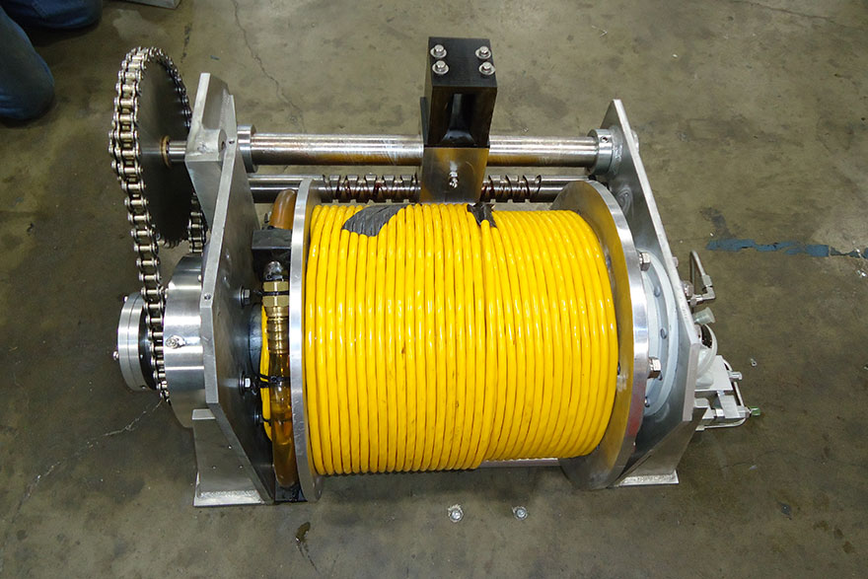
For our underwater station system, to raise and lower the solar panels, we used a high-quality winch system paired with a robust flexible umbilical cable. The winch system we selected is the CDUR-01 Umbilical Winch System from Novasub, a leader in subsea technology. This choice was driven by the need for a reliable, high-strength solution capable of operating in harsh underwater environments while providing the necessary power and communication capabilities to deploy and retrieve the solar panels.
In subsea operations, winch systems are essential for the deployment and retrieval of underwater equipment. These systems use a rotating drum to wind or unwind cables, enabling the precise control of subsea equipment at various depths. It’s Length up to 1000 meter
Cable: The umbilical cable is crucial for Supplying power & Transmission data.
- Data Transmission Method
The fixable Umbilical Cable CDUR-05 cable utilizes electrical conductors for data transmission rather than optical fiber. Specifically, it uses two distinct electrical methods for data and video transmission:
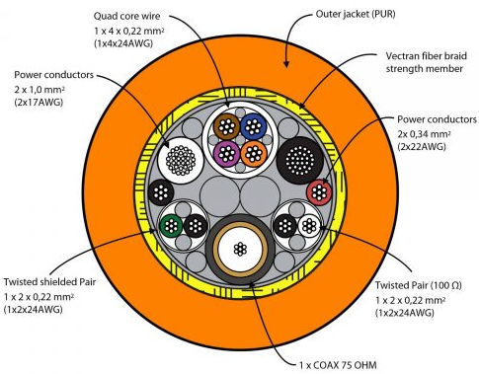
- coaxial Transmission: The cable includes a 75 Ω coaxial core for video signal transmission. This coaxial component is a recent addition that distinguishes the CDUR-05 from previous models in the series.
- Twisted Pair Transmission: The cable also features twisted pair conductors with 100 Ω impedance for alternative data transmission. This dual approach makes the cable compatible with both types of underwater camera systems.

Supplying power
The CDUR-05 umbilical cable supplies energy to batteries or other underwater systems through its dedicated power conductors, which are designed to transmit electrical power efficiently over long distances.
- Electrical Conductors for Power Transmission:
  - The cable includes 2 x 1.0 mm² (17 AWG) and 2 x 0.34 mm² (22 AWG) power conductors, which are capable of carrying electrical current to recharge batteries or power underwater equipment.
  - These conductors are rated for an operating voltage of up to 250V, ensuring compatibility with most underwater power systems.
- Energy Delivery to Batteries:
  - The electrical energy is transmitted via the copper conductors in the cable. The current flows through these conductors and is delivered directly to the battery charging system or power management unit.
  - Proper voltage regulation and current control are typically required at the receiving end to ensure safe and efficient charging of batteries.
- Voltage and Resistance Considerations:
  - The resistance of the conductors (e.g., less than 20.95 ohm/km for 17 AWG) ensures minimal energy loss during transmission, even over long cable lengths (up to 1000 meters).
  - The cable's insulation and shielding prevent energy leakage and protect against environmental factors like water pressure and temperature extremes

Winch System
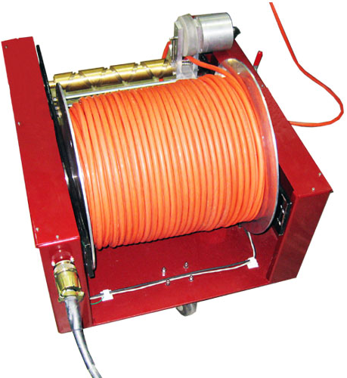
The Winch System is a critical component for deploying and retrieving underwater equipment using umbilical cables like the CDUR-05. Here's an explanation of how the winch system works, including its features and functionality
A winch system is a mechanical device used to control the deployment (lowering) and retrieval (raising) of an umbilical cable. It typically consists of:
- Drum or Reel: The cable is wound around this rotating drum.
- Drive Mechanism: Operates the drum, which can be powered electrically, hydraulically, or pneumatically.
- Control System: Manages speed, tension, and safety during operations.
- Tension Sensors: Help maintain constant tension to prevent cable damage.
- Slip Rings: Enable continuous transmission of power, data, or fluids through the cable while it is being spooled.
How the Winch System Works
- Deployment (Lowering):
  - The winch drum unwinds the umbilical cable as it lowers equipment into the water.
  - A constant-tension control system ensures smooth deployment by adjusting to factors like water depth, wave motion, and cable weight.
  - For deep-sea operations, an active heave compensation (AHC) system may be used to counteract vessel movement caused by waves, ensuring precise control.
- Retrieval (Raising):
  - The winch drum winds the umbilical cable back onto the reel to retrieve the underwater equipment.
  - Automatic systems prevent tangling or overlapping of the cable layers on the drum.

Wireless Charging System
Underwater Wireless Charging System: Electromagnetic Induction Technology
The proposed underwater wireless charging system employs electromagnetic induction, a methodology well-documented in existing research and patents. This approach facilitates efficient wireless power transfer (WPT) through the following key components
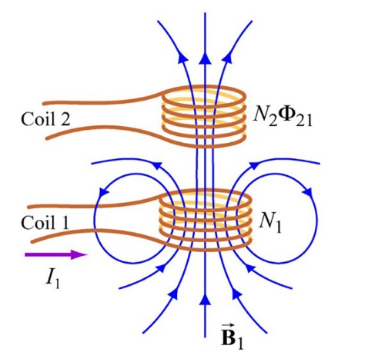
Core Technology: Electromagnetic Induction
1. Transmitter Circuit
- Oscillator: Generates high-frequency AC current
- Primary Coil: Copper wire wound around a ferrite core to create a magnetic field when energized.
- Coil turns and diameter affect inductance and transmission range.
2. Receiver Circuit
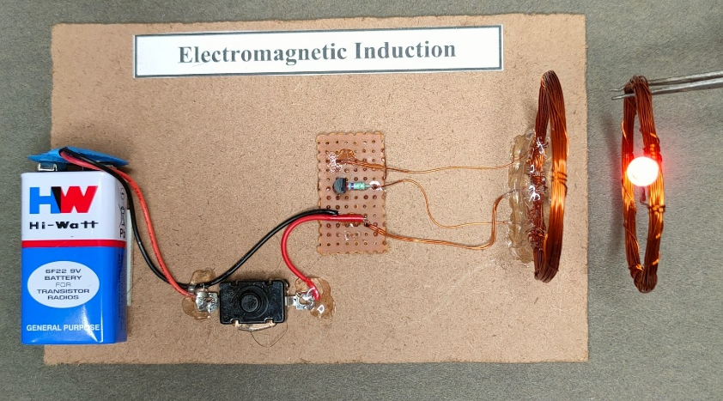
- Secondary Coil: Captures the alternating magnetic field, inducing an AC current. And its Often smaller and embedded in the device
- Rectifier: Converts AC to DC using diodes or bridge rectifiers.
- Voltage Regulator: Stabilizes output for battery charging.

Illustration of underwater wireless power transmission
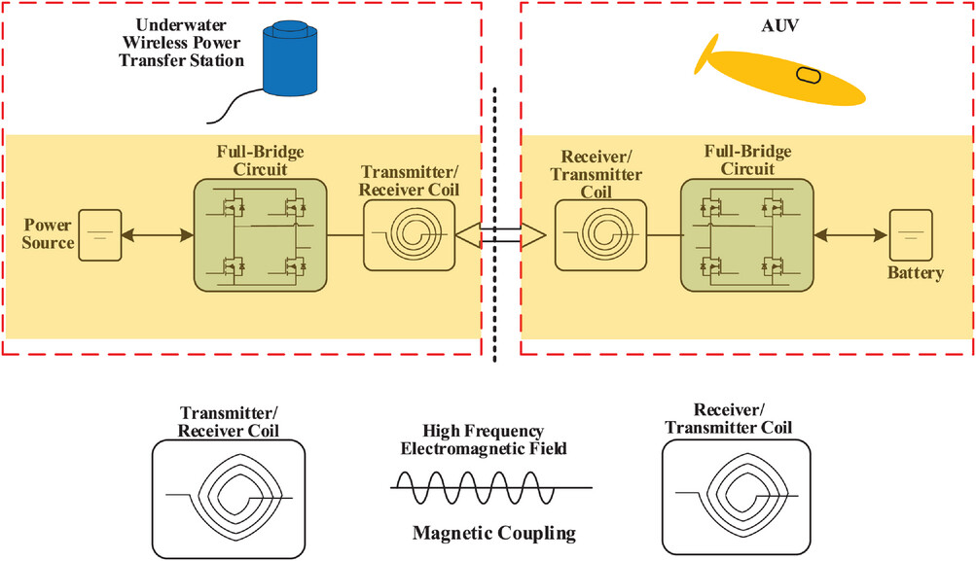

Transmitter Circuit
The transmitter circuit initiates the wireless charging process. It begins with a power source (e.g., grid or underwater station) supplying DC electricity. A full-bridge inverter circuit then converts this DC into high-frequency AC (typically kHz–MHz range) using fast-switching transistors (e.g., MOSFETs). This AC powers the transmitter coil, a precisely wound copper conductor designed to generate a strong, oscillating magnetic field. The coil’s inductance and resonant frequency are tuned to maximize energy transfer efficiency through water, which can attenuate electromagnetic waves.
Magnetic Coupling
Magnetic coupling enables wireless energy transfer between the transmitter and AUV. When the transmitter coil is energized, it creates an alternating magnetic field that penetrates the water and induces a voltage in the receiver coil via resonant inductive coupling. Key factors affecting efficiency include:
- Frequency matching: Both coils must resonate at the same frequency.
- Coil alignment: Misalignment (lateral or angular) reduces coupling efficiency.
- Distance: Energy transfer declines with increased separation but can operate over practical ranges (e.g., centimeters to meters).
- Water’s properties: While water absorbs electromagnetic waves, magnetic fields penetrate effectively with minimal loss compared to RF or capacitive methods.
This coupling method is ideal for underwater applications, as it avoids corrosion-prone physical connectors and maintains efficiency even in conductive environments.
Receiver Circuit
The receiver circuit on the AUV processes the captured energy. The receiver coil converts the alternating magnetic field back into high-frequency AC, which is then rectified to DC by a full-bridge rectifier. Smoothing capacitors may be added to stabilize the output, ensuring clean power delivery to the battery. The circuit must adapt to dynamic conditions (e.g., coil misalignment or varying distances) to maintain consistent charging. Once rectified, the DC power replenishes the AUV’s battery, enabling extended missions without surfacing.

System Integration
- The transmitter circuit generates and transmits high-frequency energy.
- Magnetic coupling wirelessly transfers this energy through water.
- The receiver circuit converts and delivers power to the AUV’s battery.
This sequence ensures efficient, autonomous charging for underwater vehicles, critical for long-term deployments.

Underwater Acoustic Communication System
Acoustic communication is the most effective method for transmitting data underwater due to the unique properties of sound waves in water. Below is a comprehensive exploration of its principles, technologies, challenges, and applications. Also relies on sound waves propagating through water. These waves consist of compressions and rarefactions, detected by receivers such as hydrophones. The speed of sound in water (~1500 m/s) is much slower than electromagnetic waves in air, which heavily influences system design.
The working principle of underwater acoustic communication system is to use transducer to convert, electrical signal into acoustic signal at transmitting end and convert acoustic signal into electric signal at receiving end. The block diagram of underwater acoustic communication system is shown in Fig.

Summary of theProject: Enhancing Seafloor Mapping with a Network of Underwater Stations
Problem Statement
Seafloor mapping remains a major challenge due to high costs, technical limitations, and harsh ocean conditions. Traditional methods using sonar and ROVs are expensive, prone to failures (e.g., the 2017 NOAA incident costing $146,000 in recovery), and leave vast areas unmapped. This hinders marine research, resource management, and hazard mitigation.
Solution: Project Depth – A Network of Underwater Support Stations
Team Cypher proposes a scalable, cost-efficient Stations Network to support Autonomous Underwater Vehicles (AUVs) during long missions. These stations act as "rest points," providing:
- Power recharging (via wireless induction)
- Data transfer (via acoustic communication)
- Docking stability (modular design)
Key Innovations & Design Challenges
- Material & Depth Optimization
  - Stations are deployed at 200m (shallow), 1,000m (mid), and >1,000m (deep).
  - Spaced 35km apart to match AUV range limits.
  - Built with HY-80 steel (high strength, corrosion-resistant, ~0.42–0.42–1.20/kg).
- Station Design
  - Two-part system:
    - Fixed base on the seafloor for stability.
    - Mobile upper section with solar panels (rises to surface for energy harvesting).
  - Winch system (Novasub CDUR-01) lowers/raises the upper section via a durable umbilical cable.
- Renewable Energy
  - Solar-powered (Risen 440W panels, ~2.28 kWh/day after losses).
  - Suoer inverter (90% efficiency) converts DC to AC for station operations.
- Wireless AUV Charging
  - Uses electromagnetic induction (transmitter/receiver coils) for cable-free power transfer.
- Underwater Communication
  - Acoustic signals transmit data (sound waves travel efficiently in water).
Advantages
- Cost-effective: Reduces reliance on expensive ship-based operations.
- Sustainable: Solar energy minimizes environmental impact.
- Scalable: Modular design allows global deployment beyond pilot regions (e.g., Red Sea).
Impact
Project Depth aims to accelerate ocean exploration, improve mapping accuracy, and support marine conservation—bridging the gap between technology, affordability, and sustainability.

